

**HANOI UNIVERSITY**

**Faculty of Information Technology**

**Software Project Management Final Report**

**Faculty: Information Technology**

**Year: Fall 2021**

**Lecturer: Nguyễn Đình Trần Long**

**Topic: Online Bookshop System**

**Group Member:**

**Phạm Quang Văn - 1801040232**

**Nguyễn Hoàng Anh - 1801040006**

**Phí Đình Đạt - 1801040060**

**Nguyễn Hoàng Nam - 1801040154**

**Table of Content**

GROUP ROLES .....................................................................................................................3

1. Project Management ………………………......................................................................4

2. Research………... …………………………………..........................................................13

**GROUP ROLES**

|  |  |
| --- | --- |
| **Members** | **Sections** |
| Phạm Quang Văn (1801040232) - Leader | Project Initialization, Primary Research, Research Analysis |
| Nguyễn Hoàng Anh (1801040006) | Secondary research, Recommendations, Planning |
| Phí Đình Đạt (1801040060) | Secondary research, Reflections, Evaluations |
| Nguyễn Hoàng Nam (1801040194) | Introduction, Project Management Plan Research Analysis |

# Part 1: Project Management

## Introduction

1. **Introduction of our group**

Our group specialize in website development which includes 20 members:

* **1 Project manager**: The primary role and responsible for the completion of the project
* **3 Architects**: in charge of design and project planning, and they are also responsible for the visual appearance of buildings and structures.
* **1 developer leader**: A leader of software engineer's exact responsibilities vary from company to company and ensuring work meets the technical requirements especially in term of coding conventions
* **7 Developer**: Perform project design and development activities according to customer specifications. Work with the Manager in developing the project plan, budget and schedule. Coordinate with management in preparing project proposals and contractual documents.
* **3 QA**: The main role is to guide and monitor the analysis, design, implementation and execution of the test cases, test procedures and test suites.

They are responsible for the quality of software development and deployment. They are involved in performing automated and manual tests to ensure the software created by developers is fit for purpose

* **1 Marketing leader**: Responsible for their company's marketing and communications strategies, as well as overall branding and image. In addition, They prepare annual marketing plans, create a calendar of campaigns and events, set the marketing budget and analyze the market and competitors.
* **3 Marketer and logisticians**: Responsible for creating an involvement chain between the customer and the product or service offered by the company. Plan warehouses and distribution centers for efficiency in both operations and capacity.
* **1 Business Analyst**: Defines needs and recommends solutions to make an organization better. When part of a project team, they ensure that the project’s objectives solve existing problems or enhance performance, and add value to the organization

1. **Scenario**
2. User logs on.
3. System displays a welcome message and requests customer ID and password.
4. User enters the customer ID and password.
5. System validates the ID and password.
6. User searches for a title by browsing or keyword search
7. System displays information about the title.
8. User selects a title to buy
9. System adds title to the customer's shopping cart
10. [Repeat 5-8 until done]
11. User is done with shopping
12. System displays shopping cart, shipping address, and billing address
13. User confirms the order and payment method.
14. System processes the order, notifies the warehouse for shipping, and issues an electronic receipt.
15. User logs off.

## Project initialization

1. **Main aim of the project**

There are three main aims. The first one is to help the bookstore owner to introduce new books to as many people as possible. The second one is to help the bookstore owner to sell books online. The final one is to help the bookstore owner to manage books easily

1. **List of objectives to achieve the aim**

To introduce books to many people, the website needs a beautiful and user-friendly interface so that people will visit the website more. To help the bookstore owner to sell and manage books online, the website needs to show all the available books and show books by book category, publication time to the book buyer and have a ‘cart’ function which allows website users to add books into the shopping cart so that they can buy. However, before buying books online, the book buyer needs to log in. The system must also have a ‘search’ function so that book buyers can easily find the book they want. They can search books by title, author, topic, subject, isbn, issn, etc. What is more, the bookstore’s customers can get information about new books through email if they subscribe. The bookstore owner can create, read, update and delete books; increase and decrease the quantity of books. The bookstore owner can see orders from customers and can decline and accept the orders. Both user and admin can perform advertising.

1. **Use case diagram of the system**

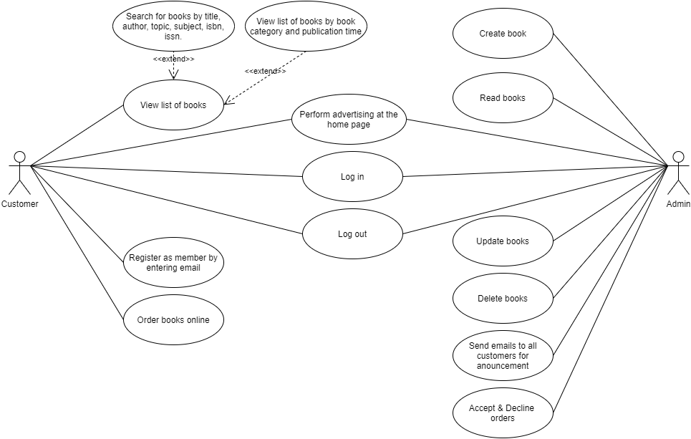

## Project Management Plan

1. **Scope**

|  |  |  |  |  |  |  |  |
| --- | --- | --- | --- | --- | --- | --- | --- |
| **IT Project Scope** | | | | | | | |
| **Project Title:** Online Bookstore System | | | | **Project Number:** 01 | | | |
| **Project Leader/Manager:** Pham Quang Van | | | | **Anticipated Project Start Date:**  Oct 18th, 2021 | | | |
| **Sponsor:** Bookshop owner | | | | **Date Prepared:** Oct 14th, 2021 | | | |
| **Project Risk Level:** Level 2 | | | | **Estimated Completion Date:**  Dec 18th, 2021 | | | |
| **Team Members:** 20 people:   * 1 Project Manager: Pham Quang Van * 3 Architects. Leader: Le Hoang Nam * 8 Developers. Leader: Phi Dinh Dat * 3 QAs. Leader: Nguyen Hoang Anh * 1 Business Analyst. * 4 Marketers & Logisticians. | | | | | | | |
| **Purpose of Project & Background:** Develop a website to promotes and sells books | | | | | | | |
| **Deliverables:** | | | | | | | |
| Product Definition | Product Design | Product  Development | Pre-Beta | | Beta | Pre-Launch | Sustaining |
| Statements of Direction | Product  Requirements Document | Release  Requirements Document | Beta  Requirements  Document | | Beta  Customer Training | Closing  Beta  Customers | User Group Participation |
| Market  Requirements Document | Features  Requirements  Documents | Product FAQ | Beta  Recruitment | | Manage Beta | Finish   Release Requirements  Document | Product Strategy Planning |

|  |  |  |  |  |  |  |
| --- | --- | --- | --- | --- | --- | --- |
| Product Roadmap |  | Additional  Requirements Gathering | Beta Training | Beta  Findings Report | Launch Planning | Competitive Analysis |
|  |  | Product Branding Packaging | Beta  Release Feedback |  |  |  |
|  | | | | | | |
| **Stakeholders:**     * Employees: IT Company with 100 employees * Investors: Bookshop owner * Customers: Bookshop owner * Suppliers: Book authors. | | | | | | |
| **Resource Requirements:**     1. Project management plan: Resource & Procurement management plan & cost baseline 2. Project documents: Project schedule, Resource calendars, Resource requirements, Stakeholder register 3. Enterprise environmental factors 4. Organizational process assets 5. Tools & Techniques: SPM tools, Pre-assignment, Virtual teams 6. Physical resource assignments, Project assignments, Change requests 7. Project management plan updates, Project documents updates 8. Enterprise environmental factors updates 9. Organizational process assets updates | | | | | | |
| Life Cycle Cost:   |  |  |  |  | | --- | --- | --- | --- | |  | Oct | Nov | Dec | | Implementation: | $1,000 | $1,500 | $1,000 | | Maintenance: | $1.500 | $2,000 | $1,000 | | Procurements: | $1,500 | $1,500 | $1,000 | | Totals: | $4,000 | $5,000 | $3,000 |   Life Cycle Cost: $12,000 | | | | | | |
| **Safety, Security, & Risks:**  Safety: Medium Security: Medium   |  |  |  |  |  |  | | --- | --- | --- | --- | --- | --- | | **Issues and Risks** | | | | | **Risk Mitigation or Contingency** | | Project design and deliverable definition is not fully completed | | | | | Define the scope in detail via design  workshops with input from subject matter experts | | Legal action delays or pauses project | | | | | Ensure all contracts are signed before starting the project.  Follow all regulatory requirements a complete stakeholder management plan. | | Project schedule understood | is | not | clearly | defined | Hold scheduling workshops with the project team so they understand the plan and reduce the chances of missed tasks | | | | | | | |

1. **Time of Project**

Project Start: Mon, October 18th, 2021

Project End: Tue, December 14th, 2021

* 18/10/2021 – 1/11/2021: Initiation, market research and backup plans

Assigned to: leader Pham Quang Van (PM)

* 2/11/2020 – 13/11/2021: Admin module design and build

Assigned to: leader Phi Dinh Dat (Dev), Le Hoang Nam (Arc)

* 13/11/2020 – 22/11/2021: User module design and build

Assigned to: leader Phi Dinh Dat (Dev), Le Hoang Nam (Arc)

* 23/11/21 – 28/11/2021: Testing

Assigned to: leader Nguyen Hoang Anh (QA)

* 28/11/2021 – 29/11/2021: Document approved build

Assigned to: leader Pham Quang Van (PM)

* 30/11/2021 – 12/12/2021: System Performance

Assigned to: leader Nguyen Hoang Anh (QA)

* 13/12/2021 – 14/12/2021: Finish the project

Assigned to: all the team

1. **Communication**

Reference: Communication.docx

1. **Risks**

Severity Table

|  |  |  |  |  |
| --- | --- | --- | --- | --- |
|  |  | Likelihood | | |
|  | 1 | 2 | 3 |
| Effect | 1 | Low | Low | Medium |
| 2 | Low | Medium | High |
| 3 | Medium | High | High |

|  |  |  |  |  |  |  |
| --- | --- | --- | --- | --- | --- | --- |
| No | Risk | Likelihood of risk | Effect of risk | Severity | Action to reduce likelihood | Action to deal with the risk when it occurs |
| 1 | Requirement is not well defined | Medium | High | High | - Have Good questions for customer to get what customer want  - Have well-defined project charter and PID | Rewrite question, project charter and PID |
| 2 | Project schedule is not clear | Low | Medium | Low | - Explain the schedule for the team so that the team can understand the schedule | - Have meetings about missed tasks and unclear tasks |
| 3 | Theft of materials, equipment | Low | High | Medium | - Set camera in the workplace  - Apply security procedures  - Have backup of materials | - Notify the police |
| 4 | Bad weather leads to loss of materials and resources | Low | High | Medium | - Put material in secure places  - Have backup of materials | - Notify appropriate authorities |
| 5 | The team has bad performance | Low | Medium | Low | - Improve workplace environment  - Give appropriate training | - Improve work environment  - Give appropriate training  - Understand what motivates them. |
| 6 | The teammate leave project | Low | High | Medium | - Pay employees good salary  - Give opportunities for employees to promote | -Replace the teammate by another teammate, if he/she is qualified  - hire other employees, if there is no replacement |
| 7 | Over budget | Medium | Medium | Medium | -The budget allowance should include reserve funds. As risks happen, allowances can be taken up from the reserves to avoid the project from failing.  -Prevent the risks that affect the project budget. | - Notify appropriate authorities |
| 8 | Key milestones and deliverables are delayed or of insufficient quality | Low | Medium | Low | - Set realistic goals for the project | - Prioritize important activities to meet the deadlines |

1. **Resources**

* **Software and hardware:**

1. 20 workstation computers (CPU core i5 or higher, with at least 4gb ram,128gb SSD and 1TB HDD).
2. A server for hosting the website.
3. Code editor (VS Code, Sublime Text...), Photoshop, Microsoft Project.
4. Window 10, MySQL database.

* **Human:**

Team members: 20

1 Project Manager, 1 Lead Designer, 2 Designers, 1 Lead Developer, 7 Developers,1 Lead tester, 2 Testers, 1 Lead Marketer, 1 Marketer, 1 Business Analysis, 2 Logisticians

Recruit candidates through interviews, different assessment, reference checks.

**Allocate project works to team members**

* **1 Project Manager:** The primary role and responsible for the completion of the project
* **1 Lead Developer:** A leader of software engineer's exact responsibilities varies from company to company and ensuring work meets the technical requirements especially in term of coding conventions
* **7 Developers:** Perform project design and development activities according to customer specifications. Work with Manager in developing the project plan, budget and schedule. Coordinate with management in preparing project proposals and contractual documents.
* **1 Lead Tester**: The main role is to guide and monitor the analysis, design, implementation and execution of the test cases, test procedures and test suites.
* **2 Testers**: Responsible for the quality of software development and deployment. They are involved in performing automated and manual tests to ensure the software created by developers is fit for purpose
* **3 Designers**: Responsible for all the resources and assumption related to the provision of design services
* **2 Marketers**: Responsible for their company's marketing and communications strategies, as well as overall branding and image. In addition, they prepare annual marketing plans, create a calendar of campaigns and events, set the marketing budget and analyze the market and competitors.
* **1 Business Analyst:** Defines needs and recommends solutions to make an organization better. When part of a project team, they ensure that the project’s objectives solve existing problems or enhance performance, and add value to the organization
* **2 Logisticians**: Plan warehouses and distribution centers for efficiency in both operations and capacity.

1. **Cost Estimation**

Reference: Cost Estimation.xlsx

## Planning

1. **Work Breakdown Structure**

Reference: Work Breakdown Structure.xlsx

1. **Gantt Chart**

Reference: Gantt Chart.xlsx

# Part 2: Research

## I. Primary Research

1. **Overview about Survey**

The main purpose of primary research is gaining requirements from the end user and then our team will use the requirements to make the system better. There are 30 book lovers who bought books on the internet, fill in the questionnaire. The questionnaire is to find out what the system should have to meet the system user’s needs. The questionnaire is filled in from 22 October 2021 to 28 October 2021.

1. **List of survey questions**
2. What is your name?
3. How should our online bookshop system look?

* Luxurious
* Simple
* Academic

1. Do you want our online bookshop system to have Dark Mode?
2. Do you use the phone or tablet to order books?
3. List things that our website should have.
4. List things that our website should not have.
5. **Summary about survey**

The pie chart gives information about how the website should look. 56.7% of the people want our online bookshop system to look simple. 30% of people like an academic interface and 10 of the people like a luxurious interface.

The pie chart gives information on whether the system should have Dark Mode. 83.3% of people want the system to have Dark Mode and 16.7% of people do not want to have it in the system.

The pie chart gives information whether the customer ordered books online. 93.3% of the people answer ‘yes’ while only 6.7% of the people answer ‘no’.

Survey participants do not want advertisement in the system and there are many additional functions that they want to have in the system.

The functions are:

* Pay for books by credit card or some prestige E-Wallet such as: Momo, airpay
* Rate books
* Leave comments for books
* Read e-book in the system
* Show a list of recommended books
* preview some pages of the book
* Add books to the wish list
* Sort books by price
* Listen to audiobooks, podcasts
* Follow the author

1. **Evaluation about Survey**

The survey is successful. 30 people filled in the form with many helpful ideas. Our team can use those ideas to improve the system.

## II. Secondary research

1. **Overview:**

- In this research, we do study about advantage and disadvantage about online buying book, which leads to we can improve the user experience better and add more interesting and useful features to alleviate the cons of buying books online.

1. **List of articles:**

- Advantages of Buying Books Online – author: Ann Simpson, publish: 23/12/2015

Available: <https://www.libreriaparadiso.com/advantages-of-buying-books-online/>

- 10 Pros & Cons of Buying Books Online – author: Puput Sparkling Letters, publish: 4/12/2016

Available: <https://pupuutc.wordpress.com/2016/12/04/10-pros-cons-of-buying-books-online/>

1. **Summary**

- Throughout two articles, we realize that buying books online has advantages also disadvantages. Here are some pros of buying books online. Firstly, users can sort, filter books by category, price, best seller and easily search whatever books they want leading to saving their time and having the best choice. Secondly, users can access and buy books anytime, anywhere, which helps users save travel costs and can buy books from far away distances. Especially, in this covid-19 time, users can avoid going outside and congregate in crowded area. The last is no limited choice, offline stores have limited space to display stocks as opposed to online stores which have huge databases and contain a lot of books. On the other hand, online books also bring about some disadvantages. First of all, the packager may make mistake about size or product. Secondly, users may take a long time to get books. Moreover, products can be damaged in shipping progress. Finally, some online books shopping require users to have credit card or paypal to pay. As you can see, online book shopping has lots of pros, but has some cons as well. Thence, we need to improve and take advantage of its pros in order to user have more comfortable experience. Similarly, we should develop features which dismiss as much possible as the cons of shopping book online.

1. **Evaluation about your understanding**

- To make the user experience better, we need to completely develop our website which has all the useful and convenient features of an online bookstore website mentioned above. Besides, our website still requires users to login and have a credit card before they place order with our products, which is the big issue mentioned in the above articles. Therefore, we will improve and change these features to make it simpler and more attractive for users, if we have more time.

## III. Research Analysis

1. **Analyze and evaluate data of survey**

56.7% of the people want the website to look simple so our team is going to design a simple interface for the website. There are 83.3% of the people who want our website to have Dark Mode so our team is going to create Dark Mode for the website. Our team is also going to design interfaces for the phone and the tablet because 93.3% of the people used the phone or tablet to order books. The survey participants suggest many functions for the system. However, our team just selects suitable functions and creates those functions for the business. The function are:

1. Pay for books by credit card or some prestige E-Wallet such as: Momo, AirPay
2. Rate books
3. Leave comments for books
4. Show a list of recommended books
5. preview some pages of the book
6. Sort books by price
7. **Evaluate tool: Google Form**

Our team chose Google Form to conduct the survey. It takes our time to find the link of the survey which is to send to the survey participants. However, Google Form is easy to use. We can create many kinds of questions in Google Form and the interface is simple and beautiful.

1. **Evaluate how accurate your interview and survey are**

The system is the online bookshop system, so survey participants should be book lovers. We select 30 survey participants who like reading books and our team chats with them individually and asks them to give honest answers, so our team thinks that the participants answer honestly and the survey is accurate. The result meets our expectations. By making the survey, our team has many new ideas to build our system better. This time, we only conducted one survey, so we think we will conduct both the survey and interview next time to get more useful ideas and build the system much better.

## Recommendations

1. **Summary about our proposed system**

An online bookstore software projects that acts as a central database containing various books in stock along with their title, author and cost. This project is a website that acts as a central book store. This web project is developed using ReactJs as the front end and Nodejs as a back-end. The MySQL database stores various book related details

1. **List of features after the survey**

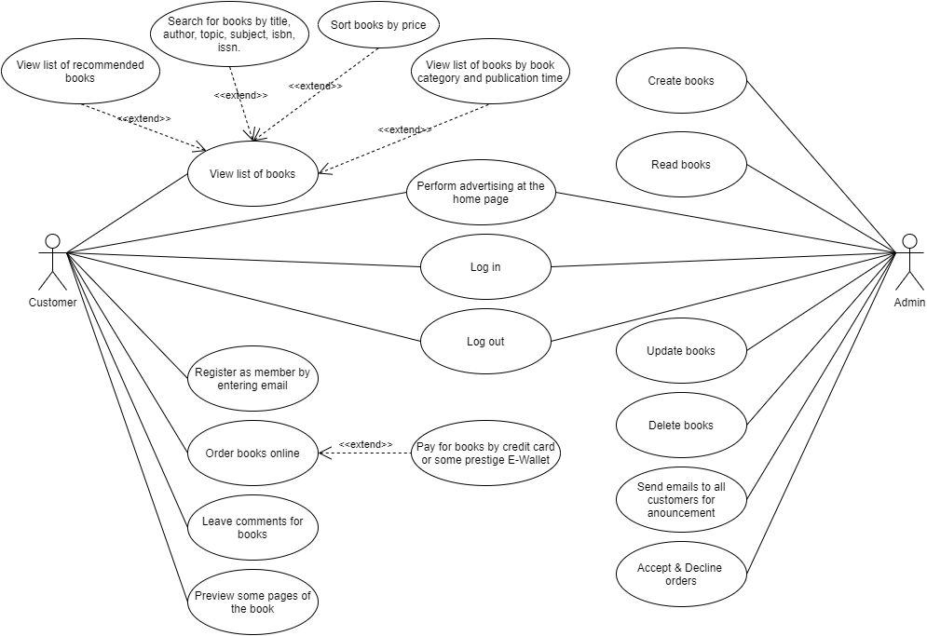

1. **Advantages and disadvantages of the system.**

* Advantages

Customers can get their book delivered instead of actually going and buying the book. They can make payment online itself.

Managing of inventory in the shop for shopkeeper becomes easier as customers are not visiting and ordering online.

This system saves both time and travelling cost of customers.

User can get to know different kinds of books that they were unaware of by just searching in the system using keywords.

* Disadvantages

The only disadvantage is if the customer receives a book that is not in proper condition or has some kind of defect then there incurs an additional charge of posting it back.

## Reflections

The primary research is about user’s expectation. It illustrates that the experiences and features users want when buying books online. We realized that the majority of these we have improved and implemented in our web application. Although, there are some great features from the survey to optimize the user experience, which our web application does not have. For example, allowing users to login using other way such as Facebook, google, and so on. Moreover, almost users who intensely do not want to create an account in order to place an order conveniently and fast. All of the above features will be researched and developed as soon as possible in the future

## Evaluations

The project management process of this project that has been completed is really close and specific with the well researched methodologies to understand how the user’s needs. The project management methodology provides the framework, processes, guidelines and techniques to manage the people and achieve the project objectives. It increases the odds of project success and then provides value to the organization, the project, the beneficiaries and the donor so that it is valued as a good methodology. The project assigns work for all architects, developers, testers and project managers, contributes to build up a good working relationship and environment so that the team performance will improve effectively. As a result, the members are directed to work in the most efficient manner possible in order to meet the team's objectives as rapidly as possible. Both the quantitative and qualitative aspects of the project are well-executed. The investigation to satisfy the project's requirements was carried out to better understand the issues, which increases the project's chances of success. The project is completed successfully and efficiently; methods and templates are produced, and they may be utilized or enhanced in the future. Improved planning also helped the initiative achieve better results. Quantitative research shows that a large percentage of the company's employees consider the project is dynamically helpful. Furthermore, it is an advantage for the project since it solves issues faster and mitigates some potential dangers before they arise. The WBS of the project helped it set out the assignments for each specialist, and the division helped to reduce the weight of managing the project. In addition, the cost of developing and implementing a project management methodology can manage expectations with stakeholders more effectively. The Gantt chart was used to estimate the time needed for the project and the amount of staff required to the tasks. It has been demonstrated the length of the project so the staff can arrange the suitable tasks in suitable time inside the project time limit.